Chapter 4, Problem 68.

Compute the value of R that results in maximum power transfer to the 10-Ω resistor in Fig. 4.134. Find the maximum power.

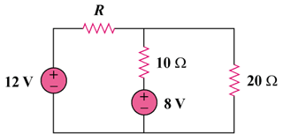

Figure 4.134
For Prob. 4.68.

